# T.C.

# HASAN KALYONCU UNIVERSITY



# Online Auction Application

# GRADUATION PROJECT REPORT

# Mahir Tekin Erdensan

# Rümeysa Kutlu

# Abdullah Burhan Başaran

# Supervisor

# Ins. Mustafa Bıçakcı

# HASAN KALYONCU UNIVERSITY

**JUNE2021 Graduation Project in Computer Engineering Department Chill**

# FACULTY OF ENGINEERING

# COMPUTER ENGINEERING DEPARTMENT

# Online Auction Application

# GRADUATION PROJECT

# IN

# COMPUTER ENGINEERING

# By

# Chill

# JUNE 2021

# Online Auction Application

# Gradauation Project

# in

# Computer Engineering

# Hasan Kalyncu University

# Supervisor

# Ins. Mustafa Bıçakcı

# By

# Chill

# JUNE 2021

Copyright © 2021 Online Auction Application

All rights reserved. No part of this publication may be reproduced, distributed, or transmitted in any form or by any means, including photocopying, recording, or other electronic or mechanical methods, without the prior written permission of the publisher, except in the case of brief quotations embodied in critical reviews and certain other noncommercial uses permitted by copyright law.

# REPUBLIC OF TURKEY HASAN KALYONCU

# UNIVERSITY

# FACULTY OF ENGINEERING

# COMPUTER ENGINEERING DEPARTMENT

Name of the Project: Online Auction Application

Name of the Student(s): Mahir Tekin Erdensan, Rümeysa Kutlu, Abdullah Burhan Başaran

Exam Date: 01-13-2021

We certify that this project satisfies all the requirements as a project for the graduation project

Assist. Prof. Bülent HAZNEDER

Head of the Computer Engineering Department

This is to certify that we have read this project and that in our consensus/majority opnion it is fully adequate, in scope and quality, as a project for the graduation project.

Ins. Mustafa BIÇAKCI

Supervisor

Examining Committee Members Signature

**We hereby declare that all information in this document has been obtained and presented in accordance with academic rules and ethical conduct. We also declare that, as required by these rules and conduct, we have fully cited and referenced all material and results that are not original to this work.**

**Mahir Tekin Erdensan Rümeysa Kutlu Abdullah Burhan Başaran**

**ABSTRACT**

**ONLINE AUCTION APPLICATION**

ERDENSAN, Mahir Tekin

KUTLU, Rümeysa

BAŞARAN, Abdullah Burhan

Graduation Project in Computer Eng.

Supervisor: Ins. Mustafa BIÇAKCI

JUNE 2021, XXXX pages

In this report we will discuss the plans, technologies, system designs, and application operation in this article, which are all essential for the application's growth. We will describe the ecosystem we have developed in the following sections of our paper. Our main goal in launching this app is to contribute to the industry's development by making it simple for interested users to engage in auctions.

In the past, auction catalogs were only sent to a select group of collectors and art enthusiasts. Our online auction app ensures that consumers have a safe and stable auction experience. All collectors, users who want to start collections, and users who want to sell their items will be able to participate in auctions without difficulty and purchase the item they want via auction thanks to our application. We hope that by using the auction system, users will be able to dispose of their products in a secure, simple, and quick manner. One of the key goals of our application is to ensure the authenticity and reliability of auctioned product offers while also reducing the possibility of fraud. It also aims to have a level playing field for users bidding. For personal verification, our application provides users' TR identification number, phone number, e-mail address, and other information. taking advantage of their expertise We assume that these checks should be performed only before users build or bid on auctions.

In the world we want to build, users should be able to openly watch and comment on auctions without having to share any personal details. We built our application around security and freedom dynamics based on this knowledge.

**ÖZET**

ERDENSAN, Mahir Tekin

KUTLU, Rümeysa

BAŞARAN, Abdullah Burhan

Bitirme Projesi, Bilgisayar Mühendisliği Bölümü

Tez Yöneticisi: Öğr.Gör. Mustafa Bıçakcı

Haziran 2021, XXXX sayfa

Bu raporda uygulamanın geliştirilmesi için gerekli olan planlardan, teknolojilerden, sistem tasarımlarından ve uygulamanın işleyişinden bahsedeceğiz. Raporumuzun sonraki kısımlarında, size oluşturduğumuz ekosistemi açıklayacağız.

Bu uygulamayı çıkartmaktaki en büyük arzumuz, ilgilenen kullanıcıların kolaylıkla bir müzayedeye katılabilmesiyle sektörün büyümesine katkı sağlamak. Eskiden müzayede, evlerinin yalnızca sınırlı sayıda koleksiyoncu ve sanatsevere gönderdiği kataloglardı. Çevrimiçi müzayede uygulamamız, kullanıcılarına güvenli bir açık arttırma oturumu sağlamaktadır. Uygulamamız sayesinde bütün koleksiyoncular, koleksiyon yapmak isteyen kullanıcılar ve ellerindeki eşyaları satmak isteyen kullanıcılar zorluk yaşamadan müzayedelere katılabilecek ve istediği eşyayı açık artırım ile sata alabileceklerdir.

Bu uygulama ile birlikte, uygulamamızı kullanan kullanıcılara satmak istedikleri eşyalarını güvenli, kolay ve hızlı bir şekilde, açık artırma usulünü kullanarak elden çıkarmalarına olanak sağlamayı hedefliyoruz. Uygulamamızın ana amaçlarından biri, açık artırmaya çıkan bir ürün için gelen tekliflerin doğruluğunu ve güvenilirliğini sağlamak ve dolandırıcılık riskini erken aşamada engellemek. Ayrıca teklif veren kullanıcılar için adil bir ortam oluşturmaya çalışmaktadır.

Uygulamamız, şahıs doğrulaması için kullanıcıların TC kimlik numarası, telefon numarası, e-posta vs. bilgilerinden yararlanmakta. Bu doğrulamaların sadece kullanıcıların bir açık artırma oluştururken veya bir açık artırmaya teklif sunmadan önce yapılmasına gerektiğine inanıyoruz. Oluşturmak istediğimiz ortamda kullanıcıların kişisel bilgilerini paylaşmadan özgürce istedikleri müzayedeleri izleyebilmelerini ve yorum yapabilmelerini istiyoruz. Bu bilgiler altında uygulamamızı güvenlik ve özgürlük dinamikleri altında geliştirdik.

**ACKNOWLEDGEMENTS**

We would like to thank our supervisor Ins. Mustafa Bıçakcı for his great effort and help on development progress for online auction application with his advices. Also, we thank to Asst.Prof. Bülent Haznedar and Asst.Prof. Saed Alqaraleh for their great effort for graduation project.

Table of Contents

1 PREFACE 15

2 INTRODUCTION 16

2.1 Purpose and Scope 16

2.2 Problem Statement 16

2.3 Solution Statement 17

2.4 Contribution 17

3 LITERATURE REVIEW 18

3.1 Why do people need this application? 18

3.2 What is the reason for the application? 18

3.3 What does this app do? 19

3.4 What Are Similar Applications? 20

3.4.1 Foundation.app 20

3.4.2 PeraMezat 20

3.4.3 eBay 20

4 SOFTWARE REQUIREMENT SPECIFICATION 21

4.1 Introduction 21

4.2 Aim 21

4.2.1 Target Group and Reading Recommends 21

4.2.2 Product Scope 21

4.2.3 References 22

4.2.3.1 What is Django? 22

4.2.3.2 What is Web Browser? 22

4.2.3.3 What is PIP? 22

4.2.3.4 What is MYSQL? 22

4.2.3.5 What is CloudFlare 22

4.2.3.6 What is SSL? 22

4.3 Common Description 23

4.3.1 Common Statement 23

4.3.1.1 System Interfaces 23

4.3.1.2 Interfaces 23

4.3.1.3 Hardware Interfaces 23

4.3.1.4 Software Interfaces 24

4.3.1.5 Network Communication Interfaces 24

4.3.1.6 Memory Constraints 24

4.3.1.7 Browser Compatibility 25

4.3.1.8 Site Adaptation Requirements 25

4.4 Product Functions 26

4.4.1 First Impression 26

4.4.2 Membership Login 26

4.4.3 Declaring the Type of Product 26

4.5 User Features 27

4.6 Limitations 27

4.7 Assumptions and Dependencies 28

4.8 The Requirements 28

4.8.1 Particular Requirements 29

4.8.2 User Requirements 29

4.8.2.1 User Registration 29

4.8.2.2 User Validation 29

4.8.2.3 User Login 30

4.8.2.4 Chatting 30

4.8.2.5 Comments 30

4.8.2.6 Starting a Auction 30

4.8.2.7 Updating Auctions 30

4.8.2.8 Finding a Auction 31

4.8.2.9 Discussing a Auction 31

4.8.2.10 Defining of Auction Method 31

4.8.2.11 Making a Bid for Auction 31

4.8.3 System Requirements 32

4.8.3.1 User Registration 32

4.8.3.2 User Validation 32

4.8.3.3 User Login 32

4.8.3.4 Starting a Auction 33

4.8.3.5 Bidding a Auction 33

4.8.3.6 Listing Auctions 33

4.8.4 Non Functional Requirements 33

4.8.4.1 Performance Requirements 33

4.8.4.2 Compatibility Requirement 34

4.8.4.3 Security Requirement 34

4.8.5 Functional Requirements 34

5 SYSTEM DESIGN SPESIFICATION 35

5.1 Introduction 35

5.2 User Interface 35

5.2.1 Home Page 36

5.2.1.1 Head Part of Home Page 37

5.2.1.2 Middle Part of Home Page 38

5.2.1.3 End of Home Page 39

5.2.2 Register Page 40

5.2.3 User Login Page 41

5.2.4 List of Categories Page 42

5.2.5 Auction Profile Page 43

5.2.5.1 Auction Profile Main Section 44

5.2.5.2 Share This Auction Menu 45

5.2.5.3 Report This Auction Menu 46

5.2.5.4 Product Description Section 47

5.2.5.5 Product Condition Report Section 48

5.2.5.6 Recent Bids for Auction Section 49

5.2.5.7 Recent Comments for Auction Section 50

5.2.6 User Profile Page 51

5.2.6.1 User Profile Main Section 52

5.3 System Architecture 53

5.3.1 System Software Architecture 53

5.3.1.1 Front-end Architectures 53

5.3.1.2 Back-end Architectures 55

5.3.1.3 Django Architecture 56

5.4 Database Design 57

5.5 Use-Case Diagrams 58

5.5.1 Non-Registered User Use-Case Diagram 58

5.5.2 Registered User Use-Case Diagram 59

5.5.3 Identity Verified User Use-Case Diagram 60

5.6 Sequence Diagrams 61

5.6.1 Register Sequence Diagram 61

5.6.2 Login Sequence Diagram 62

5.6.3 Create an Auction Sequence Diagram 63

5.6.4 Comment an Auction Sequence Diagram 64

5.6.5 Send Bid to an Auction Sequence Diagram 65

5.7 Class Diagrams 66

6 REFERENCES 67

**List of Figures**

Figure 1: Browser Compatibility for JavaScript 25

Figure 2: Market share of web browser 28

Figure 3: Minimum web browser versions 29

Figure 4: Design of home page 36

Figure 5: Mockup of top part of home page 37

Figure 6: Mockup of middle part of home page 38

Figure 7: Mockup of end part of home page 39

Figure 8: Mockup of user registration page 40

Figure 9: Mockup of user login page 41

Figure 10: Mockup of list of categories page 42

Figure 11: Design of auction profile page. 43

Figure 12: Mockup of auction profile main section 44

Figure 13: Mockup of share this auction menu 45

Figure 14: Mockup of report this auction menu 46

Figure 15: Mockup of product description section 47

Figure 16: Mockup of condition report of product section 48

Figure 17: Mockup of recent bids for auction section 49

Figure 18: Mockup of recent comments for auction section 50

Figure 19: Mockup of user profile page 52

Figure 20: Request structure on Django 56

Figure 21: Database Structure 57

Figure 22: Non-Registered user use-case diagram 58

Figure 23: Registered user use-case diagram 59

Figure 24: Identity verified user use case diagram 60

Figure 25: Register sequence diagram 61

Figure 26: Login sequence diagram 62

Figure 27: Create an auction sequence diagram 63

Figure 28: Comment an auction sequence diagram 64

Figure 29: Send bid to an auction sequence diagram 65

Figure 30: Class UML 66

# PREFACE

The study that is being presented is the culmination of Hasan Kalyoncu University's Computer Engineering Department Graduation Project. The online auction application is a project aimed at allowing both collectors and people who want to buy and sell objects to do so via the internet. Mustafa Bıçakcı is the lecturer in charge of this project. This curriculum guide's advice, approach to issues, and caring attitude toward the students to whom they give solutions are all identical. Beyond the project and different aspects of it, lecturer Mustafa Bıçakcı gave us the feeling of becoming a hero as a decent person, doing the best you can for your tasks in life and caring for his students as if they were friends. As engineers, it was one of the most valuable lessons we learned. Throughout this process, lecturer Mustafa Bıçakcı was extremely helpful in notifying us when he was available. For this project, instructor Mustafa Bıçakcı introduced us to his close friend Yakup Keskindağ. Yakup Keskindağ Django expertise came in handy during the coding phase of our project. He, like Mustafa Bıçakcı, was always in touch with us and shared his experience. We would like to express our gratitude to Mustafa Bıçakcı and Mr. Yakup Keskindağ for their invaluable assistance, expertise, and experience.

**ERDENSAN**, Mahir Tekin

**KUTLU**, Rümeysa

**BAŞARAN**, Abdullah Burhan

# INTRODUCTION

This part is the part that allows us to understand the project.

## Purpose and Scope

Our app aims to give people the opportunity to purchase items they want safely through auctions and to provide financial benefits through selling products they don't need at a price that is possibly higher than their value.

## Problem Statement

Web services and applications have influenced information exchange and expanded its usage as a result of the widespread use of the Internet, and web applications that allow for several transactions are the subject of attacks because they include different information such as personal information, bank account information, and corporate information. The safety of these environments is inextricably linked to the safety of web applications. When it comes to security threats, OWASP (Open Web Application Security Project) stands out as the most detailed company. OWASP maintains a list of the most significant web vulnerabilities based on data from different security organizations in order to improve the security of software and web applications. SQL Injection is ranked first in the top 10 web application vulnerabilities study published in this list. Authentication tokens are usually sent over the network and are stored on both the frontend and backend. An intruder may exploit this flaw to manipulate user-supplied data in order to manipulate backend SQL statements.

When user input (Login, Registration, Message, and Comment Fields) is sent to an interpreter as part of a command or query, the interpreter is tricked into running unwanted commands and gaining access to unauthorized data. As a consequence, the attacker has the ability to inject malicious content into weak spots. Many of the information on the websites, including confidential details such as username and password, can be read from the website's database, and its data can be updated, as well as database management operations. Broken Authentication and Session Management is another form of vulnerability. For each valid session, websites usually create session cookies and session IDs. In web applications, session cookies are used to differentiate one user from another. Furthermore, the user's credit card numbers, and so on. It can contain crucial information, such as. This transparency is caused by the application's identity and session management features not being implemented. An attacker could hijack a session and gain unauthorized access to the device if they exploited this vulnerability, and there are several others like it.

## Solution Statement

Users who want to sell their products via auctions can find it difficult to attract buyers based on this information. Unlike physical auctions, our application offers the items that users wish to sell to a larger number of customers. While publishing the product he wants to sell in our app, the user can add a price, description, and images to reach more customers. It can quickly categorize the commodity it wishes to sell so that only the appropriate buyers receive it. When we consider the customers' perspective, our application allows them to quickly find the goods they want and securely sell them. Buyers can explicitly ask the seller questions about the product without bidding, or they can disagree with other users about it. The competitive factor among auction participants is taken into account by our application, which ensures its reliability. To prevent malicious software from attempting to expose user information, such as SQL injection our application employs 256-bit SSL encryption

## Contribution

We save time because users can quickly locate the items they are searching for on the app. This is advantageous to the consumer because we have a free application. It's a huge plus that the customer can choose the product he or she wants from a large number of options.

# LITERATURE REVIEW

In this project, our goal is to provide our users with a platform where they can easily sell their items or buy the items they need. The most important issue for us in these buying and selling transactions is to provide our users with an environment where they can make a fast, reliable and easy transaction. Preliminary research on the subject is presented in this section.

## Why do people need this application?

Because physical auctions are often an expensive event, these auctions are mostly held for famous and valuable art, historical artifacts or inventions. Such auctions usually take place in a public and crowded environment, especially due to the COVID-19 epidemic that has affected the whole world in the current period, such crowded events are prohibited by the authorities of the country where the event will be held. In short, our application both creates an auction environment for low volume sales and allows these transactions to be carried out without any physical contact. People are trying to avoid such crowded and physical contact activities that have become dangerous especially with this epidemic.

## What is the reason for the application?

Nowadays, with the widespread use of the internet, such shopping sectors have started to become digital. The purpose of our online auction application is to provide an environment where people can sell their items through an auction in the easiest and most reliable way. In addition, to create an extra source of income for users who make sales through our application by establishing a marketplace for sellers.

## What does this app do?

Users can access this application whenever they want, using the devices they want. Our application can be accessed with any internet browser. Our users can add products 24/7 or participate in any auction. In order to sell a product in our application or to send an offer for a product, the user must be registered in the system and have already confirmed the necessary information. The buyers can offer the products they want to bid, as they want, within the framework of the necessary conditions, and they can withdraw their offers whenever they want. Buyers can protect their privacy while making bids and can participate in auctions held with open bidding method by hiding their personal information from other users.

When starting an auction, the seller can choose two types of procedures. The first of these is the open offer method, where participation is open to everyone and the offers made for the product are shared with the public. This method is generally used for small volume sales, buyers can view other offers and make their own offers by comparing these offers. The other method we offer to our users is the closed mail method. In this method, while the buyers send an offer to the product they want to send a bid to, if the product is put up for sale by closed mail, the information of the bidder and the bidder is hidden from the public and from the seller and is shared only with the seller after the auction is completed. In this method, the main purpose is to protect the confidentiality of buyers and offerers in high volume sales. Sellers who want to put a product up for auction must specify the required title, description, categories, photo, start date of the auction, starting bid, end date of the auction and end criteria of the auction when starting the auction. The seller can edit this information later and cancel the auction if she/he wishes. Using this information, the application creates an auction under the selected categories in the system and tracks this auction until it is canceled or until the auction reaches the end criteria. The user with the highest bid wins the auctions that reach the end criteria. The application removes the bid of the winning user and makes the user who made the next highest bid a winner, as long as the user who won the auction does not pay within 1 day. After the payment of the winning buyer, the system waits for the seller to deliver the product to the buyer, and the auction is terminated after the buyer confirms that the product has been received.

Our application observes payment and shipping transactions in order to ensure that these buying and selling transactions are carried out in the most reliable way and that there is no risk of fraud. If the winner makes a payment, this payment is held and transferred to the seller if the buyer approves the product. The seller must ship the product within 1 week after the buyer payment. In case of not shipping, the seller's evaluation score is reduced and the payment made by the buyer is refunded.

## What Are Similar Applications?

There are many online auction applications on the Internet. Below are a few similar examples.

### Foundation.app

Foundation is an online auction site where artists and art lovers meet. It is used to discover and invest in creative digital artworks. [1]

### PeraMezat

It is an online auction site where Ottoman, European antiques and various collections are established to bring together collectors and those who want to make collections. Users can buy an antique item of their choice by bidding at the auction with a certain time created by the website.[2]

### eBay

eBay is the world's most comprehensive auction and online sales site, founded in 1995. Having entered the market only with the online auction model during the first years of its establishment, eBay later became the most popular sales platform by offering different sales models. Thanks to eBay, billions of people can get rid of their extra items in their closets and contribute to their budgets. [3]

# SOFTWARE REQUIREMENT SPECIFICATION

## Introduction

In this software requirement specification section, we will talk about background and minimum requirements for online auction application.

## Aim

Online auction application aims to make a environment for his user that easily sell or buy products. In the same time with help of online payment methods, application create a comfortable and secure way to build a market place. Another important features of online auction application are control over scams and frauds with from identity authentication using user Tc. identification number, phone number and email addresses. With this features all fake users and scams will be blocked. Inside our website all collectors easily can find the valuable items.

### Target Group and Reading Recommends

It can be used with the readers of item collectors and selling owners who aim to see this project from a real life example by reading the scope of application. Web developers will refer to the general idea and flow of the project’s architectural design. The person responsible for managing this project development will refer to this document to manage each of this team.

### Product Scope

The target of the project as stated above, our purpose is aim to make an environment for people that wants to buy or sell products with online auctions. The price of starting bid will have declared buy sellers. Bidders and seller can argue with each other for prices.

### References

In reference part we will talk about outside technologies we have been used.

#### What is Django?

Django, is a high-end web framework developed with Python programming language. Django has been developed by talented developer and now publishing by Django Software Foundation. [4]

#### What is Web Browser?

Web Browser(s), help us to connect with WWW (World Wide Web). When a user wants to access a webpage, web browser sent a requests to the server and prints returned data to users. Web Browser works as a decoder like a bridge between user and server. [5]

#### What is PIP?

Pip, is a packet installer and management app has been developed with using Python programming language. Pip firstly developed by Ian Bicking [6] and licensed under MIT license. Pip is an open source project and up to the present there are already 527[7] developer has been worked on pip development.

#### What is MYSQL?

MySQL, is a database management system developed with using c++ and c programming languages. For non-commercial user, MySQL published with under GPL license. MySQL has 38.9%[9] market share on database management.[13]

#### What is CloudFlare

Cloudflare, inc. USA based, established in July 2009. It is a content distribution network encryption protocol used in 81.2% [10] of websites. Cloudflare encrypts user information such as password, electronic mail, username, phone number and ipaddress with SSL (3.1.4.6) using a reverse proxy server in the connection between the backend and frontend of websites.12]

#### What is SSL?

SSL, is an encryption protocol used in data traffic between computer networks, designed and developed to provide secure communication. 51.8% of the websites on the Internet use this protocol. [11]

## Common Description

This section will provide background information on our online auction application. We will provide information about the external systems of our application. We will explain how we take advantage of some of the technologies that our application uses while working.

### Common Statement

We can compare our website with apps in the similar apps section. Let's start with eBay, which is among those we've listed. EBay is a global brand that sells to different countries of the world or offers the opportunity to buy products from different countries. Our site will be a nationwide brand, and buying and selling transactions will take place within the country. We also have things in common and one of them is that users can find products from any area they want and buy or sell these products wherever they are in the country. Another feature is that it is possible to find valuable products / artifacts, books, clothes, even toys on our site. Last but not least, auction and security. In order to participate in the auction on eBay, we need to create an account and enter certain information about our own account, such as username, password, credit card information. This feature is also valid on our site. Users can participate in auctions by passing certain authentication stages.

#### System Interfaces

In online auction application, there’s only one depedency that is going to be uset to manage auctions and look for their ending criteria. Except that, the system will be independent.

#### Interfaces

In this section, we will detail all the interfaces that support while development of our online auction application.

#### Hardware Interfaces

Our system uses different hardware interfaces at the back-end and front-end. We have to maintain a consensus of servers in the backend that grows in proportion to the number of users of our application. Considering the current number of users, we are using a VDS system that will run our background system. The environments and software required for the operation of the application we developed in this VDS system are provided by the hosting company. Since we do not perform any operation or data storage on the front-end hardware interface, it does not create a big problem.

#### Software Interfaces

We are developing our application on two sides. Back-end and Front-end, we use different technologies and software languages to develop and implement our application in these areas. For Back-end we are using latest stable version of Django 3.2. Also we are using Python 3 officially recommended by Django. In every step of development, we are taking advantage of latest version of Visual Studio Code version 1.55.0. In Visual Studio Code we are taking help of freelance developer’s extensions. For manage Online Auction Application databases we are using MySQL 8.0.

#### Network Communication Interfaces

We are using different HTTP protocols for communication on Back-end and Front-end for our Online Auction Application. We use CloudFlare SSL (3.1.4.5 and 3.1.4.6) protection in all API requests to secure the communication between this frontend and the backend, which is one of the most important points of web applications, and to observe the safety of our users. Communications between Back-end and Front-end are usually about registering, logging in, adding products, submitting offers, etc. We use CRUD, i.e. Create, Read, Update, Delete methods in many important data exchanges. In all data transactions, a CRUD transaction sent from the frontend to the back is answered with a data package, and these packets are made readable in web browsers by using HTML with the frontend programming language.

#### Memory Constraints

Since our application is a website, it can be easily accessed from any device running a web browser. Users need a minimum of 256-512MB of ram.

#### Browser Compatibility

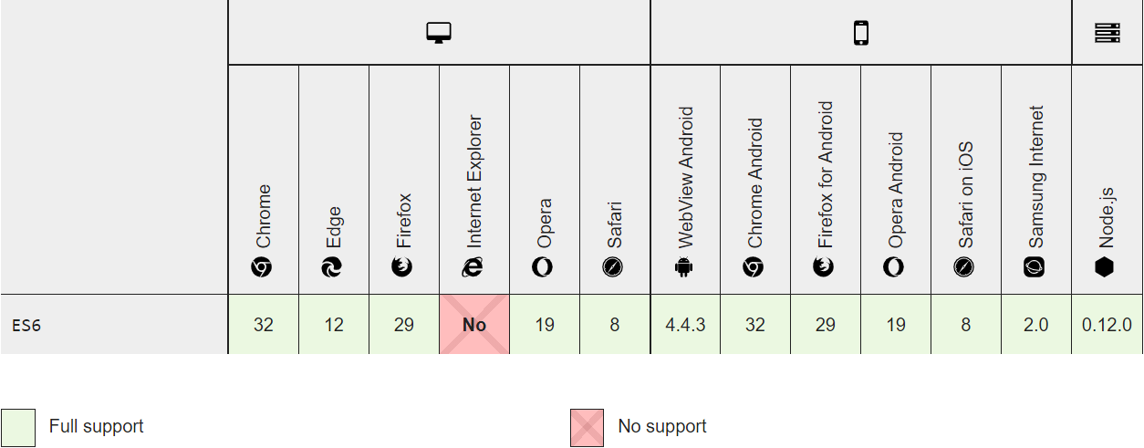

Figure 1: Browser Compatibility for JavaScript

#### Site Adaptation Requirements

Because of we develop our Online Auction App with using Django, Django makes this parts easier.

## Product Functions

In this section we will detail how we describe the system's handler for users. We will introduce important issues for our users such as money back, sending offers, offer times.

### First Impression

Users will be welcomed with the introduction page of our application. It will explain the system to users in a short, clear and understandable way with visuals.

* Application features will be explained to the user with help of illustrations.
* User will be given forward-looking explanations and instructions.
* The user will be explained what they can do with the application.

### Membership Login

The user needs to be authenticated by the system to bid or create a new auction.

* Users must enter their personal information into the system.
* Each user must have a unique password and e-mail adress.
* User can login with using his/her own password and e-mail address. If he has a trouble while logging in, he can reset his/her password with his/her e-mail.
* When the user logs in successfully, the system redirects the user to the home page.
* The users cannot start an auction or bid on any auction for any product while unregistered. Unregistered users can fallow the auctions organized by open bid method.

### Declaring the Type of Product

Auctions often contain a wide variety of products. With our online auction application, we offer various categories for our users to put their products. All freedoms on product categorization are on to our userThe user determines the starting bid, category and ending criteria for the auction. The user can hold different auction sessions for different products at the same time.

* The products for auction are listed on our website.
* Users can list auctions according to the category they want
* Users can add their favorites to the products. Each product shows how many favorites and statistics.

## User Features

Our Online Auction Application can make transactions 24/7. The end criteria and end time of each auction are determined according to the seller's request. The seller can change the information of the product in the auction or end the auction. Users can message or comment on the product with other buyers or the seller during the auction session. The use of the application is free for users, the system does not restrict or redirect any users. The reliability of buyers participating in the auction is measured by the previous purchases of the participating buyer. Buyers can send bids to the auctions they want, but buyers with a confidence vote of less than 3 cannot send any bids. Sellers can auction the products they want, but if the seller has not completed the requirement in past sales transactions, the confidence vote decreases. A seller with a confidence vote of less than 3 cannot start an auction for any product.

## Limitations

* All users using any web browser can access the Online Auction Application anytime, anywhere.
* Users who want to create an auction or submit a bid to an auction in the Online Auction Application must be registered and identity verification verified.
* Users can view and comment on the products they want after registrationRegistered users who want to put a product up for auction or to submit a bid for a auction must identity verification verified.
* After users who want to verift his/her identity verification should enter their Turkish Identity Number, phone number and e-mail, the system tries to confirm this information. After the confirmation process, the user's confidence is increased to 10 points.
* These data must be provided by the user, the system cannot randomly generate any data.

## Assumptions and Dependencies

Since our application is a website, general traffic will be provided through web browsers. Since our application operates as a website, it will work on any device that supports a web browser.

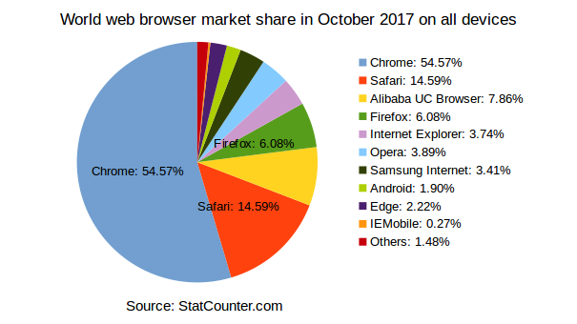

Figure 2: Market share of web browser

As seen in this picture, Chrome holds half of the web browser market share. Considering this information, we focus on development through the chrome browser.

## The Requirements

In this section we will talk about the general requirements of our application. The system needs some requirements for user account management, offer management and product management. For example, our application requires Turkish Identity Number verification to prevent fraud, scams and bot accounts. We ensure that there is not more than one account with the same Turkish Identity Number. The main purpose here is to try to create a fair and reliable environment for our users without extra account and fake accounts.

### Particular Requirements

In this section, we will divide the general requirements section into two parts. We will examine the general requirements under the user requirements and system requirements..

### User Requirements

Users can easily use our application on any device with a web browser that supports HTML5 and ES6 javascript. Specific versions of some browsers commonly used on the Internet are in the figure down below.

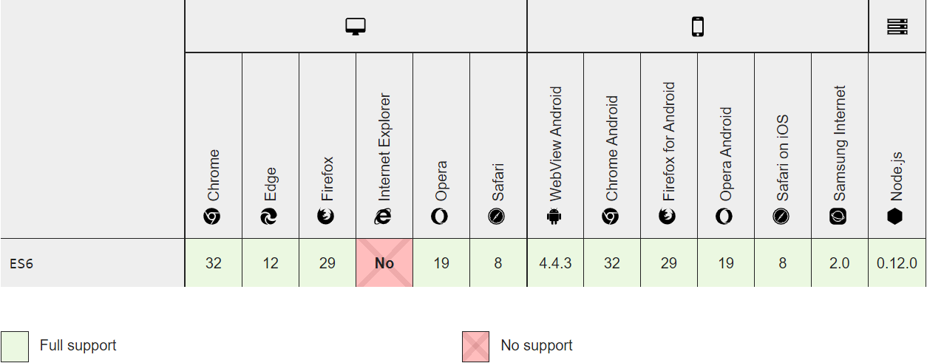

Figure 3: Minimum web browser versions

#### User Registration

Users must to have a private session to perform certain operations. For example, they need to be registered in the system to start an auction, to bid on an auction, to comment on an auction, or to ask a question to the seller.

#### User Validation

Even if users are registered, we require users to identity verification in order to prevent any fraud and bot accounts. To complete this identity verification, users must verify their Turkish Identity Number, E-mail address and phone number. Users who have not yet been verified will not be able to create an auction for any product or submit a bid to an auction.

#### User Login

Previously registered users can log in to the system from any device or log out whenever they want.

#### Chatting

Users can chat with any user they want. Users can comment on any auction or a product among themselves. Users who want to use this feature must be registered in the system and verify their identity verification.

#### Comments

Registered users can comment on an item and auction they want and socialize with other buyers in the comments. Comments can be deemed harmful and users can be reported and controlled by the administrator.

#### Starting a Auction

Registered and identity verification verified users can start auctions for the products they want. When starting an auction, the seller is obliged to enter some identifying information for the product he/she wants to sell by the auction. Identifying information such as a product title, product description, product photo and product tags for the product the seller wants to sell must be provided before the auction begins. The seller of the auction must add various dates and information to the system to manage the auction. In order to start an auction, the seller must specify the auction start bid, the auction start date, end date, and end criteria. In addition, when the user starts the auction, two different methods should be selected, the open bid method or the closed envelope method.

#### Updating Auctions

Sellers can revise their auction products at any time. For example, if the user has entered incorrect information about the product features they want to sell, they can update this information. The user cannot make any changes that will disturb the course of the auction. The seller cannot make any changes to the auction start date, end date, start bid, auction method and auction end criteria.

#### Finding a Auction

Buyers can participate in the auctions they want to participate, with a special token created for the auction, or they can reach the auction they want by filtering the product tags or browsing between categories. For use this features there is no need to be registered user.

#### Discussing a Auction

Users can use the comment feature of the auction to initiate a discussion with other bids or other users for an auction they wish to discuss. Before a user can comment on an auction, he/she must first register.

#### Defining of Auction Method

When creating an auction, the seller can create the auction using two different methods.

* Open Bid Method: The auction is open to the public and anyone can bid for the auction as they wish.
* Closed Envelope Method: The auction begins publicly, but all bids are kept until the end of the auction, taking into account the safety of the bidder from the seller and other bidders.

#### Making a Bid for Auction

Before a user can bid on the auction, he / she needs to verify his/her identify verifaction (3.8.1.2). Users who have completed their identity verification can place a bid above the starting bid price in ongoing auctions. Users can submit bids to the auctions held with open bidding method, by hiding their identities or open to the public.

### System Requirements

This section contains some detailed pieces of information about user requirements in terms of system requirements.

#### User Registration

* Registration Page; will have e-mail, password, password repeat, user and phone number sections.
* The application will check whether these fields are checked or not. If any of them are empty, a error message will be sent to the user.
* E-mail and user name information will be scanned in the system, if a user previously registered with the same information is found, the user will be warned.
* When the registration is completed, users will be transferred to the identify verification page.

#### User Validation

* Registered users will be asked to identify verification according to their wishes.
* Email verification will be done first on the identity verification page.
* An e-mail containing a code will be sent to the user for e-mail verification and the code will be verified.
* After the e-mail verification, the user will be asked if they want to verify their phone and Turkish identity number.
* Thus who want to verift ther identity will be verify

#### User Login

* In login page; will have e-mail and password and login sections
* The application will check whether these fields are checked or not. If any of them are empty, a error message will be sent to the user.
* The e-mail and password information entered by the user will be scanned in the system and, if correct, the user will be directed to the home page.

#### Starting a Auction

* The seler can use the start a new auction page to start a new auction.
* The seller must enter product details such as product title, product description, product image, product tags to start an auction on the Start new auction page.
* In order to start a new auction, the seller must enter the start date, method, end date, start bid and end criteria related to the management of the auction on the start new auction page.
* When the user presses the save button after entering all the information, this information is saved in the database via API.

#### Bidding a Auction

* When a buyer wants to send a bid for an auction, he/she must click send a new bid button on auction page.
* The buyer must enter a price for his/her bid on the send a new bid page.
* After the bid is saved, the bid is added to the bids list according to the method of the auction and saved with the database via API.

#### Listing Auctions

* The auctions that are not yet completed are listed on the homepage under various categories and tags.
* When the buyer clicks on a listed product, the user will be directed to the product page.
* Products remain in the list until the auction is completed, completed products are removed from the lists.

### Non Functional Requirements

This section will explain all of the non-functional requirements.

#### Performance Requirements

Approximately 99.9% of user requests are answered within 1.5 seconds on average without any packet loss. Because of we are using cloudflare system and cloudflare has a proxy servers at Turkey, local users will access to the Online Auction Application with having 40 ms ping and 0% packet loss. We support our users 24/7 with the hosting provider we cooperate with.

#### Compatibility Requirement

Our application is compatible with all devices that support any web browser. For minimum versions of web browser that our online auction application support described at 4.8.2 with figure number 3.

#### Security Requirement

With help of Django, google Recaptcha and CloudFlare systems all data transfers between front-end and back-end are under high security. In addition, since our application uses SSL encryption, our system protects our users from 3rd party access and hacktivist events.

### Functional Requirements

* User must verify his/her identity to start an auction or to bid on an auction. The app supports non-identity verified users to comment on auctions.
* The application supports non-registered users to view open auctions
* Users can list auctions by category
* Users can list auctions according to their tags
* When sellers start an auction, they can invite others with the special token created for his/her auction.
* Users can update their personal information
* Users can change their passwords and phone numbers
* Sellers can cancel auctions
* Sellers can change their auction information
* Buyers can bid on the product they want
* Buyers can withdraw their bids at any time.

# SYSTEM DESIGN SPESIFICATION

## Introduction

In this section, we will detail the following topics of our online auction application; System architecture, UI&UX designs, database design, use-case and sequences diagrams.

## User Interface

We have chosen a minimalist and user-friendly design to enhance our users' experience in our online auction application. In this section, we will introduce our design to you with mockups.

### Home Page

As the user first accesses our application, they will encounter with the “home page”. Home page of application is dynamic and generated especially for each user. Home page could change by, if use has session.

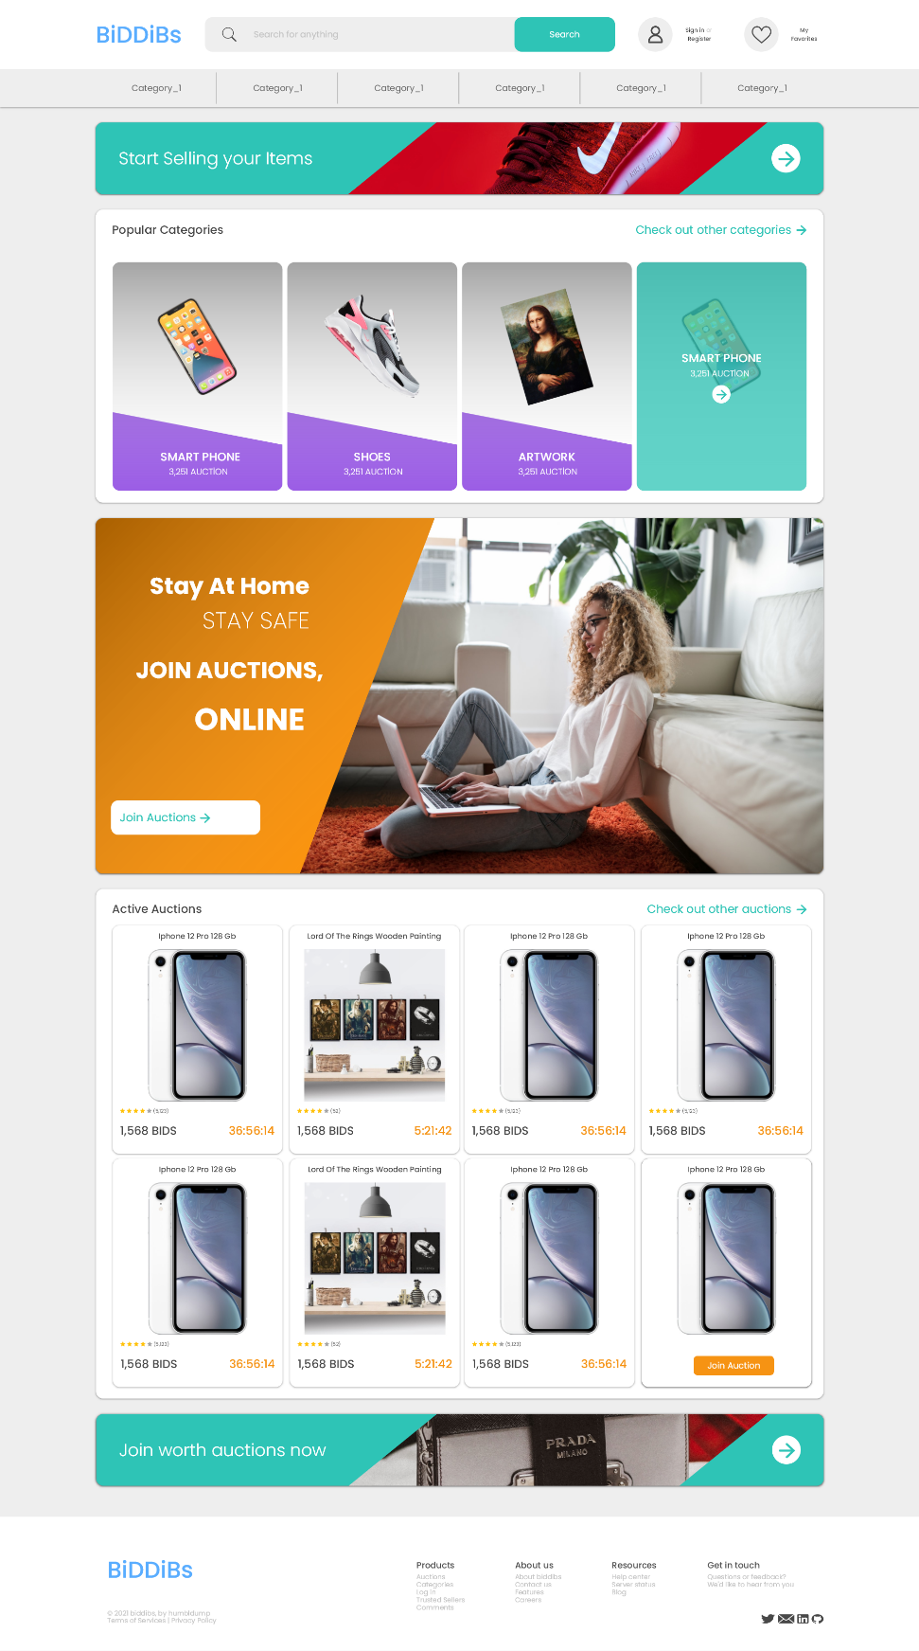

Figure 4: Design of home page

#### Head Part of Home Page

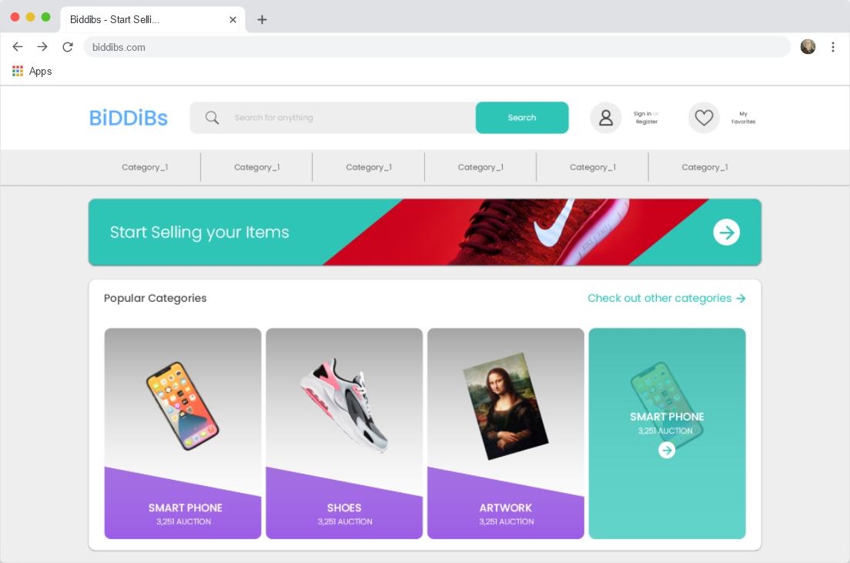

Figure 5: Mockup of top part of home page

**We will take a look to top part of home page with 3 sections. At the top of the page, there is a header menu just like every page, a card that encourages our users to sell their items and a list of the most popular categories sorted based on the total number of auctions created.**

* **Header menu on every page**
  + **Application logo**
  + **A search box that helps to user for find the auctions**
  + **User menu for registered users**
  + **Favorites menu for users**
  + **List of top categories**
* **Card that encourages our users to sell their items quickly.**
* **Quick access menu with the most popular categories**

#### Middle Part of Home Page

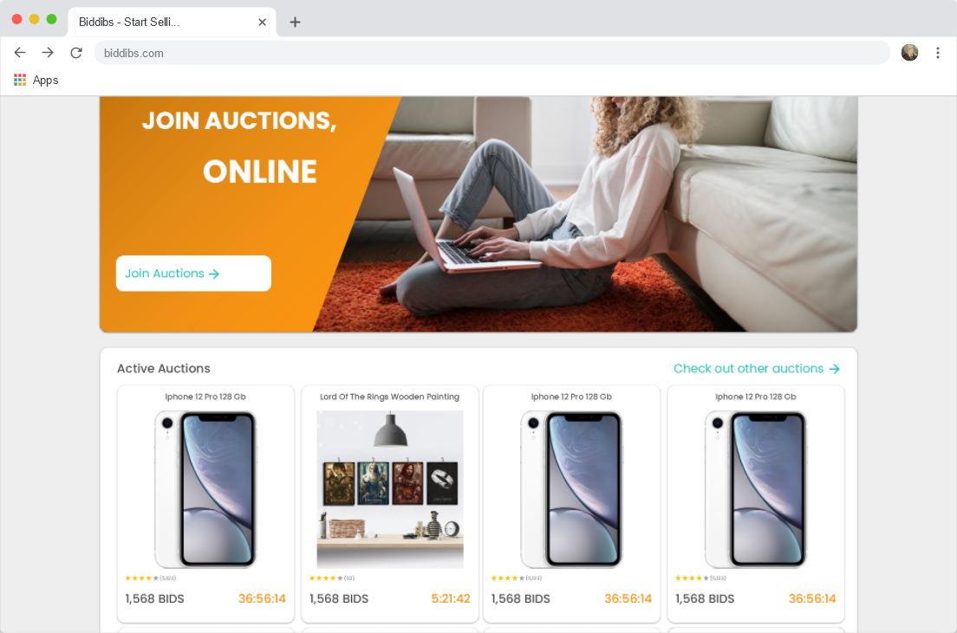

Figure 6: Mockup of middle part of home page

In the middle section of the homepage, there is a card encouraging our users to participate in auctions. On this card, there is a button named “Join auctions”. When a user clicks “Join auctions” button they will redirect to list of the recent created auctions.

Also in the middle of the home page, there is a short list of randomly selected active auctions. At the right top of this list, there is a button named “Check out other auctions”. When a user clicked that button application will redirect user to list of the recent created auctions. The items in the auctions listed in this section include the name, picture, total attendance, product average, and auction time remaining.

#### End of Home Page

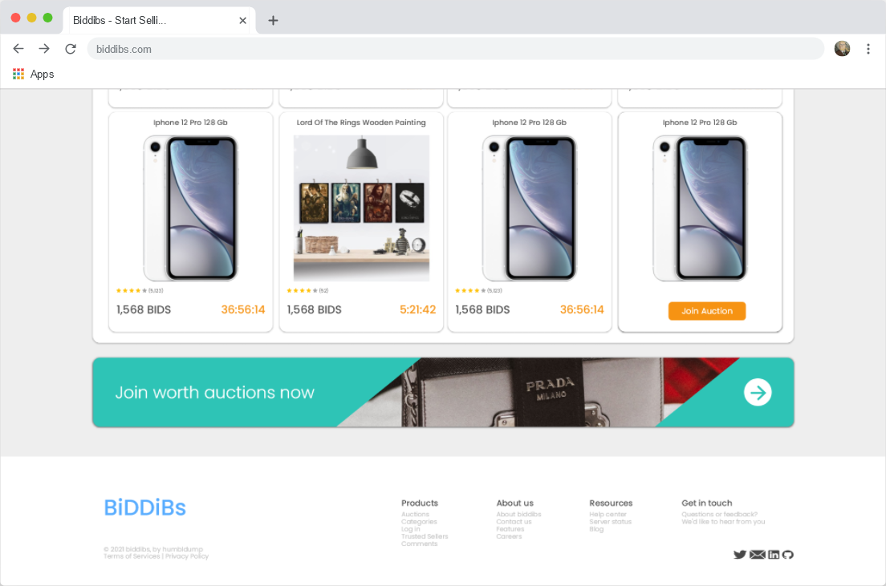

Figure 7: Mockup of end part of home page

**In this section, there is a card that makes it easy for our users to list high-priced auctions, which we call “Worth auctions”, with a minimum bid of over 5.000 TL. Users who click on this card are redirected to the page where the worth auctions are listed.**

**At the end of the home page, there is footer menu which is common for to the all pages, footer includes;**

* **Application logo**
* **Copyright info**
* **Terms of services and privacy policy links**
* **Social media links of application**
* **Products, about us, Resources and get in touch sections**

### Register Page

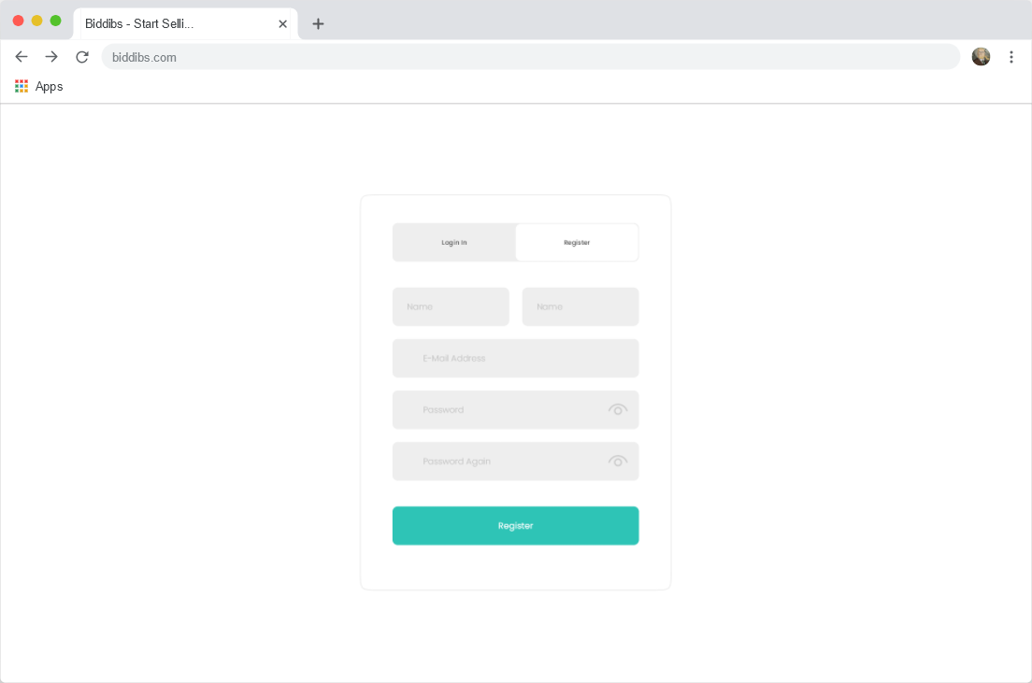

Figure 8: Mockup of user registration page

In order for users to have certain privileges, they must first register on the registration page. Users need to enter 5 information as shown in figure 5. in order to register;

* Name: User must enter their first name
* Last Name: User must enter their last name
* E-Mail: User must to enter an e-mail address that has never been used in the application before
* Password: User must enter minimum 6-character password
* Password Again: User are required to re-enter the password they entered in the password section, for verification purpose

If the user clicks "Register" after filling in the required information, the system checks that the user is a real person with google recaptcha. After bot verification, the system scans the user's information in the database and if it finds a user who has already registered with the user's email address, the user is warned and redirected to the login page.

### User Login Page

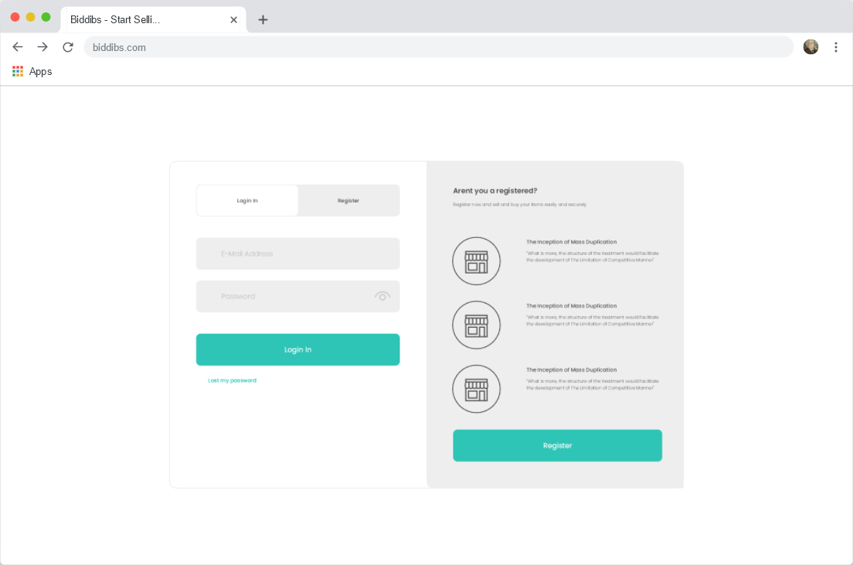

Figure 9: Mockup of user login page

On this page, the system welcomes users who are not registered or logged in with two sections. In the section on the right, if the user has not registered, there is a card that explains why he/she should register and provides quick access to the registration page. On the left, there are 2 sections that allow entering the necessary information to identify the user.

* E-Mail: A unique e-mail address used by the user when registering to the application
* Password: The minimum 6-character password that the user used while registering to the system

After the user fills in the required information and clicks the login button, the system checks that the user is a real person with google recaptcha. After verifying that the user is not a bot, the system scans the user's email address and password in the database and checks that they are correct. Login information verified user is redirected to home page. If the e-mail address entered by the user is not found in the database, the user is warned and the register button is focused.

### List of Categories Page

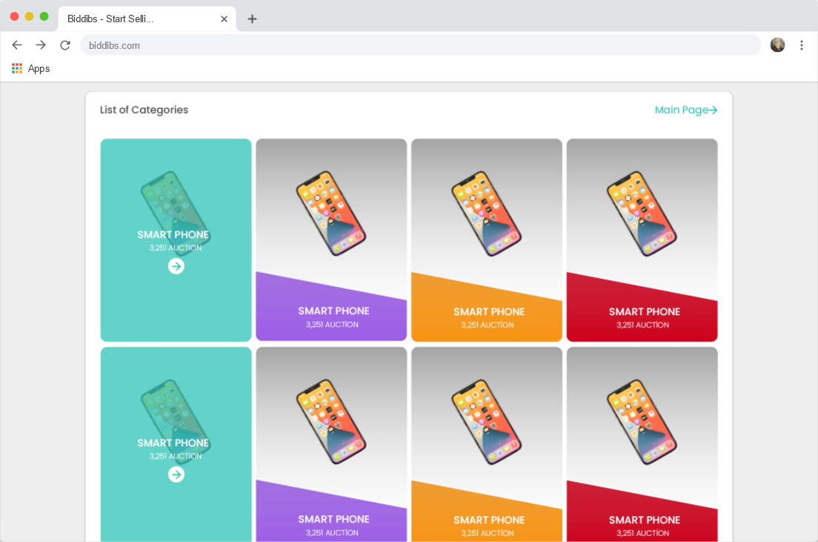

Figure 10: Mockup of list of categories page

On the list of categories page, there is a list of all categories set by the admin. Categories, sorted by the total number of auctions and on each category card; There is the category name, the total auction and the picture of the category. There is a button on the top right of the category list to redirect the user to the home page.

### Auction Profile Page

When a user clicks on an auction they are redirected to that auction profile page. This page contains sections for promoting a major auction and for the user to participate in that auction.

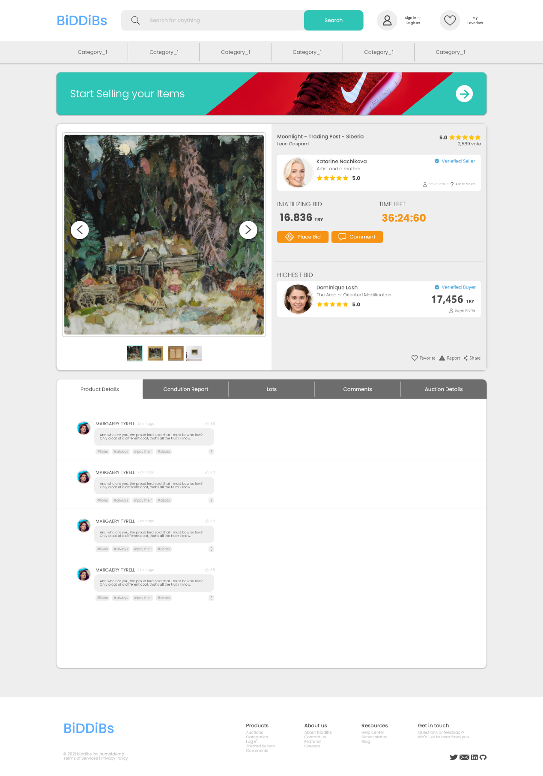

Figure 11: Design of auction profile page.

#### Auction Profile Main Section

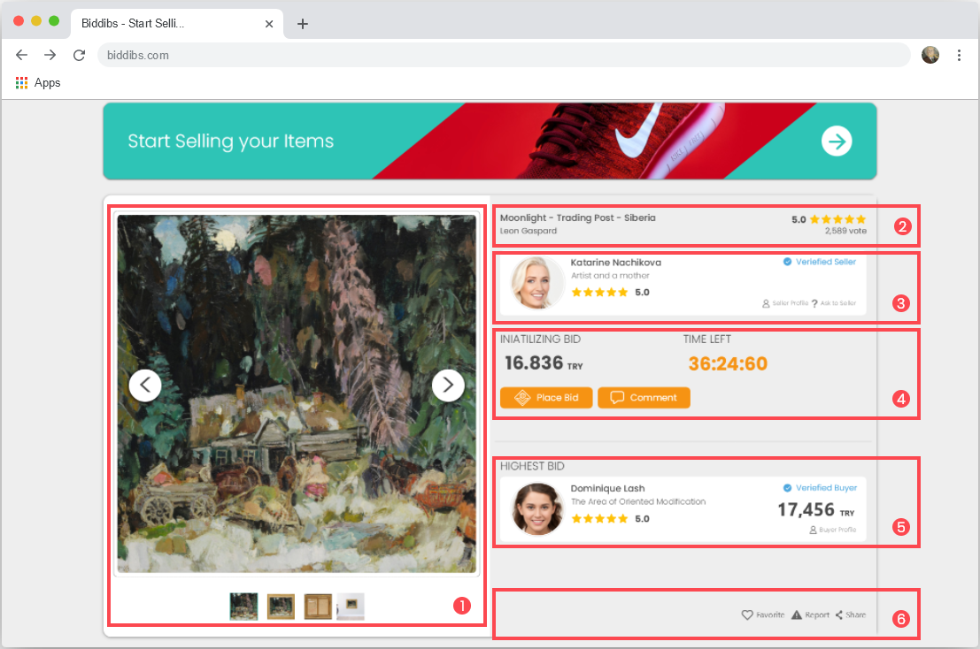

Figure 12: Mockup of auction profile main section

We can examine this section as 6 parts;

* 1- Product Pictures:
  + This section contains original pictures of the product supplied by the seller
* 2- Product Title:
  + At the left part, there is product name and product creator.
  + At the right part, there is the average rating, which is the result of user voting of the auction.
  + Users can rate auctions with using starts above “average rating”
* 3- Seller Information’s:
  + Seller profile picture
  + Seller first and last name
  + A short description written by the seller
  + Seller average rate
  + A badge for showing that the seller’s identity has been verified
  + A button for redirect the users to seller profile
  + A button for the ask questions to seller
* 4- Auction Information’s;
  + Start bid amount
  + Remain time for the auction ends
  + A button for send bids to the auction
  + A button for send comment to the auction
* 5- Highest Bid:
  + Bid sender first and last name
  + Bid sender profile picture
  + A short description written by bid sender
  + Bid sender average rate
  + A badge for showing that bid sender’s identity has been verified
  + Total amount of the bid sent by the bid sender
  + A button for redirect the users to bid sender profile
  + A button for the ask questions to bid sender
* 6- Bottom Menu:
  + A button that helps to user for add auction to their favorites
  + A button that helps to user for report an auction
  + A button that helps to user for share an auction

#### Share This Auction Menu

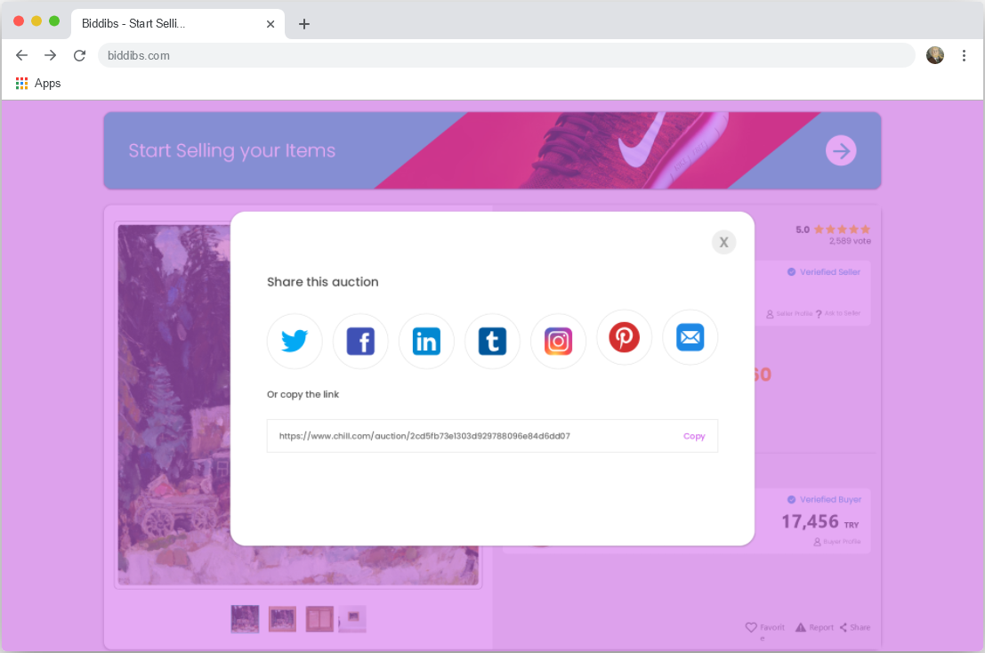

Figure 13: Mockup of share this auction menu

In this section, the user can share the auction they want to share on the social media platforms they want or copy a unique link of the auction by clicking the copy button and send it to the person they want.

#### Report This Auction Menu

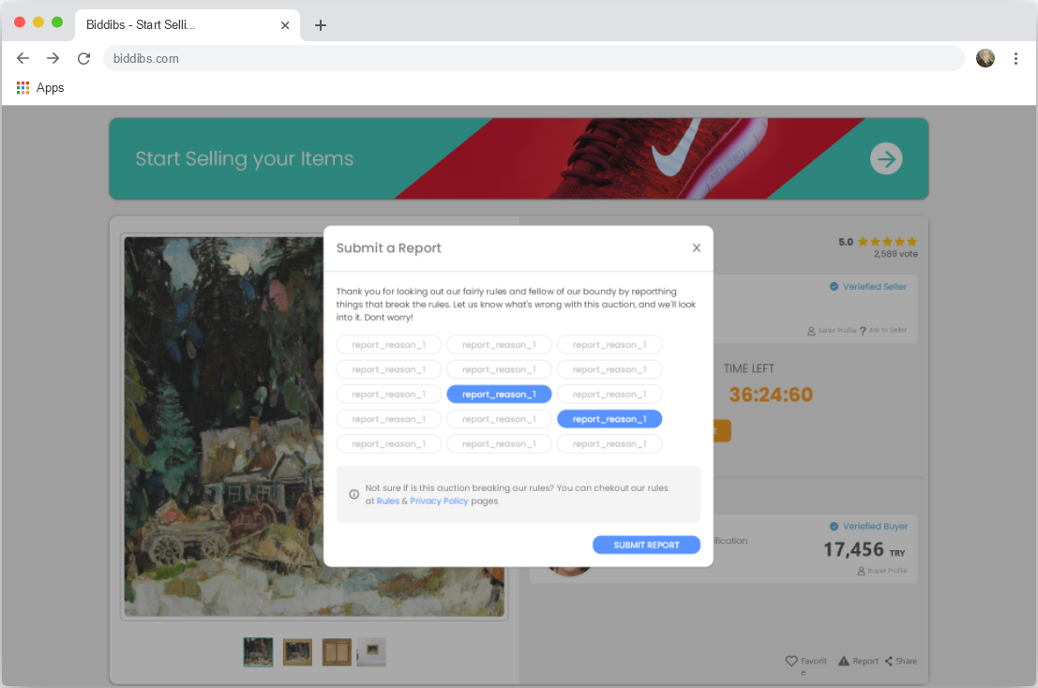

Figure 14: Mockup of report this auction menu

In this menu, the user can report an auction that he/she finds inappropriate or inaccurate

* In the selection section, user can select the title he/she wants to report the auction
* The user is warned that he/she must read the rules and privacy policy first before sending a report, and the user can be quickly redirected to the necessary pages to read the rules or privacy policy if he/she desired.

When the user clicks “Submit report” button after filling in the required fields, if the user not logged in system will redirect the user to the login page. If user already logged in system will save report information in the database to be forwarded to the management team and a report sample will be sent to the user by the e-mail.

#### Product Description Section

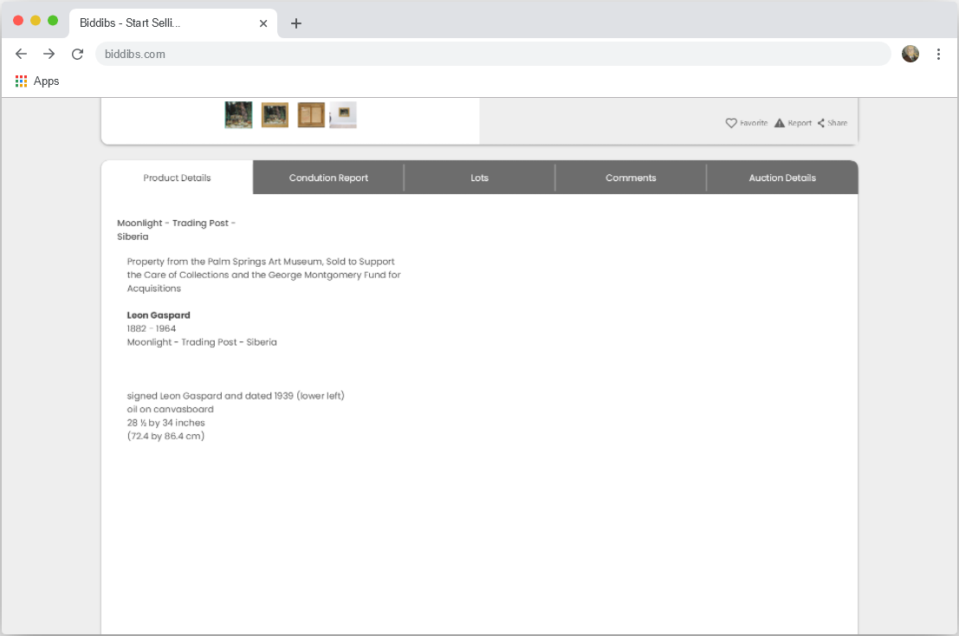

Figure 15: Mockup of product description section

In this section, users are shown the detailed description of the product provided by the seller.

#### Product Condition Report Section

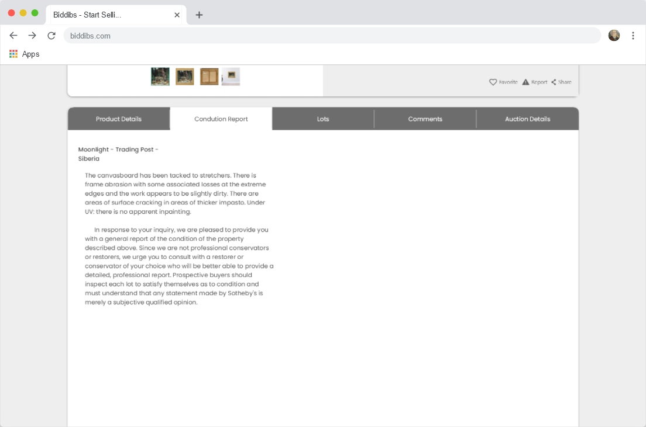

Figure 16: Mockup of condition report of product section

In this section, the information provided by the seller about the condition report of the product is shown to the user.

#### Recent Bids for Auction Section

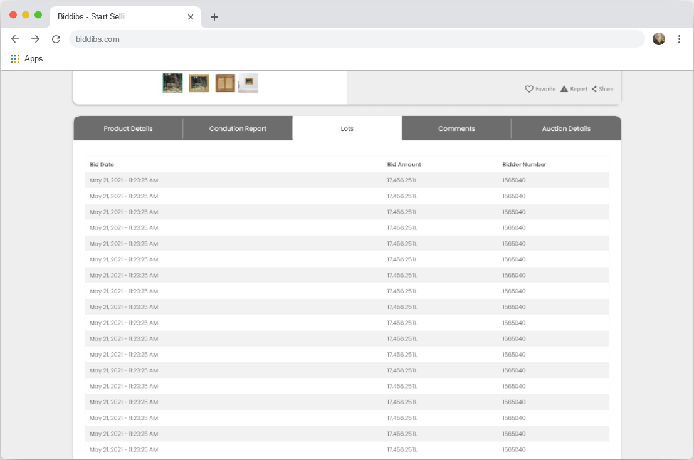

Figure 17: Mockup of recent bids for auction section

In this section, the last bids for the auction; The bid submission date is displayed with the bid amount and the bidder's user number.

#### Recent Comments for Auction Section

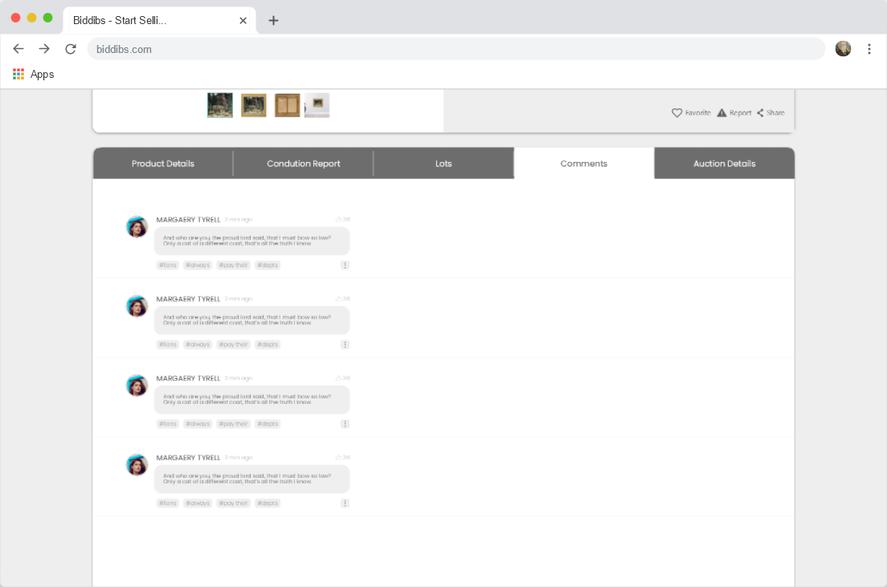

Figure 18: Mockup of recent comments for auction section

This section provides lists of the last comments submitted for an auction. Registered user can send comments to an auction whenever they want with using “Sent Comment” (5.2.5.1) button. Recent comments submitted for an auction are listed here, that comments include; sender profile picture, sender first and last name, comment content, comment keywords and a comment menu. With using comment menu user could report a comment or reply a comment.

### User Profile Page

Each registered user has a unique profile page. This page contains the user’s own personal information. For example, this page contains, user profile picture, user first and last name, user description and average rating of the user are included.

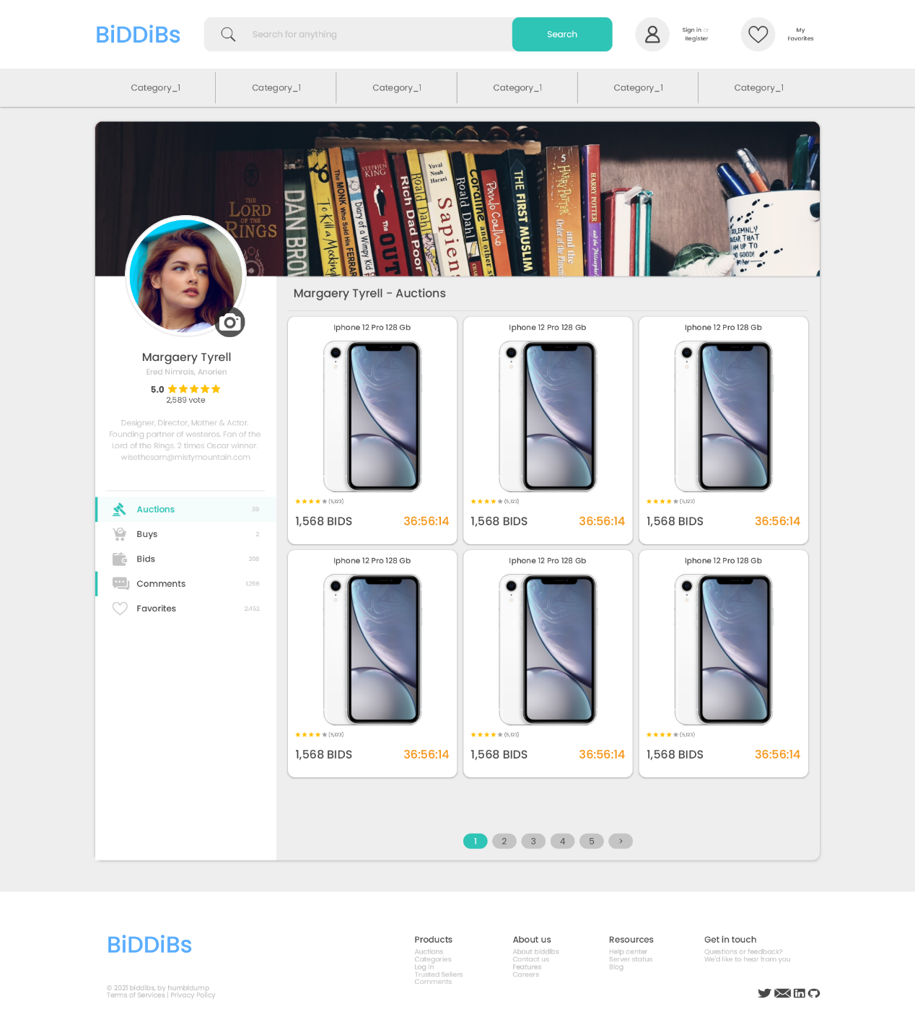

#### User Profile Main Section

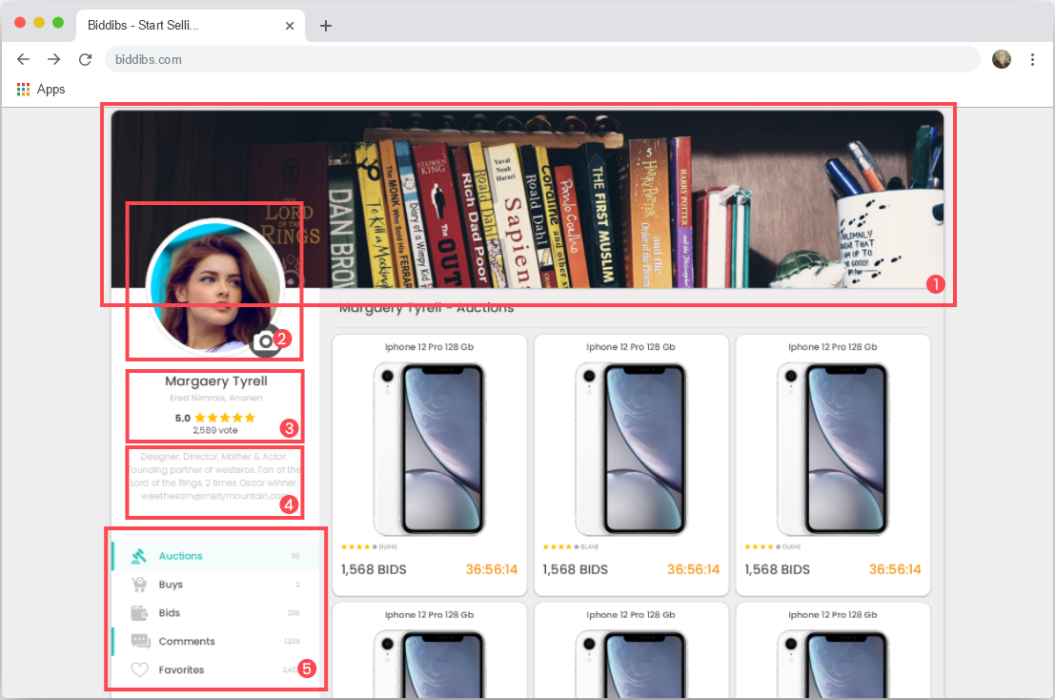

Figure 19: Mockup of user profile page

A user’s profile consists of the following 5 main sections:

* 1- Cover Page: Users can choose the ones they want among 10 cover images presented to them and they can display cover image on their profiles to the other users.
* 2- Profile Picture: User profile picture
* 3- User Information’s:
  + User first and last names
  + Short Description, a brief information about users which entered into system by the user
  + User Rate, new users start with 5 points after identity verification. This rate may change based on the past purchases and sales.
* 4- User Description: A long description entered into the system by the user. This long description only appears on the user’s profile
* 5- User Menu:
  + Auctions, this menu lists the auctions that the user has created before
  + Buys, list of the auctions that the user has recent participated in and won
  + Bids, list of auctions where the user has recent submitted bids

## System Architecture

In this section of report, we will describe the main and sub system architecture of application.

### System Software Architecture

At the front-end of application will works on pc, mobile and other devices which supports internet browsers. At the back-end of application all of the operations will be handled by Django.

#### Front-end Architectures

In this part, we will provide you with information about the development of the front-end architecture presented to the user in our application

|  |  |
| --- | --- |
| Development Environment | Visual Studio Code |
| Add-ons | Live Server, JavaScript (ES6) code snippets |
| Interface Design | Lunacy |

The development environment for front-end is Visual Studio Code which is a source code editor. Because of front-end build with HTML5, CSS3 and JavaScript, Visual Studio Code and some Visual Studio Code add-ons are the better chose for fast and most efficient code editor in this field. Especially Liver Server, developed for Visual Studio Code, helps us a lot in front-end development.

At the front-end of our application, we followed a minimalist and modern design path in order to increase the user experience. In this area; We used a professional graphic design application powered by artificial intelligence called Lunacy. Lunacy helped us a lot in getting our dream design into a template before we started front-end development.

|  |  |
| --- | --- |
| Programming Languages | HTML5, CSS3, JavaScript, SASS, Django |

HTML5 is the latest version of the hypertext markup language for frontend development of websites today. CSS3 is used in text and format formatting of web pages developed with HTML5. Dynamically running large-scale websites also use JavaScript, which is a back-end development language. In this project, we use JavaScript and various JavaScript libraries developed and supported by developers that focus on improving operation reliability and speed.

|  |  |
| --- | --- |
| JavaScript Libraries | MD5, jQuery, jQuery-confirm, Recaptcha |
| Style Sheet Libraries | Font awesome, Google Fonts |

The MD5 library, one of the JavaScript libraries we use, is developed as open source on Github. The MD5 library helps us to use text, password and link encryption methods.

JQuery is a JavaScript library that speeds up the JavaScript programming language and makes it easier to use. In addition, the jQuery-confirm library we use helps us create menus such as sending warnings and confirmations to our users.

Recaptcha library is a library published by Google that ensures the reliability of dynamic websites users sign up and login process. Recaptcha allows users to verify that the user is not a bot by considering their past actions or comparing them to a challenge when performing a form action.

Font awesome, one of the libraries we use extra for text and format formatting in frontend development, acts as a free icon archive. Also, Google Fonts is a font and icon archive database published by Google.

#### Back-end Architectures

In this section, we will detail our system API that provides communication between the front-end and back-end of our application, and the API’s that perform the operations between our application and external services.

|  |  |
| --- | --- |
| Development Environment | Visual Studio Code |

Visual Studio Code helps us a lot while working on back-end development. Just like in front-end development, Visual Studio Code allows us to work in different environments.

|  |  |
| --- | --- |
| Programming Language | Python, Django |
| Database | MySQL |

Although it has not yet found the value and market share it deserves in Turkey, Django is very close to breaking new ground in web development. We believe that Django will grow even more in the future and eliminate outdated technologies on web development industry. We think that Django, which has been developed with the possibilities of High level software language such as Python, is the best choice in a large and dynamic application where many different transactions such as Online Auction take place, with its advantages in terms of security and speed. We also plan to maximize our application with development packages released by expert developers.

With a usage rate of approximately 39% of internet applications, MySQL is the database management system we trust most in terms of high data capacity, the most reliable storage of this data and the speed of performing the necessary operations.

#### Django Architecture

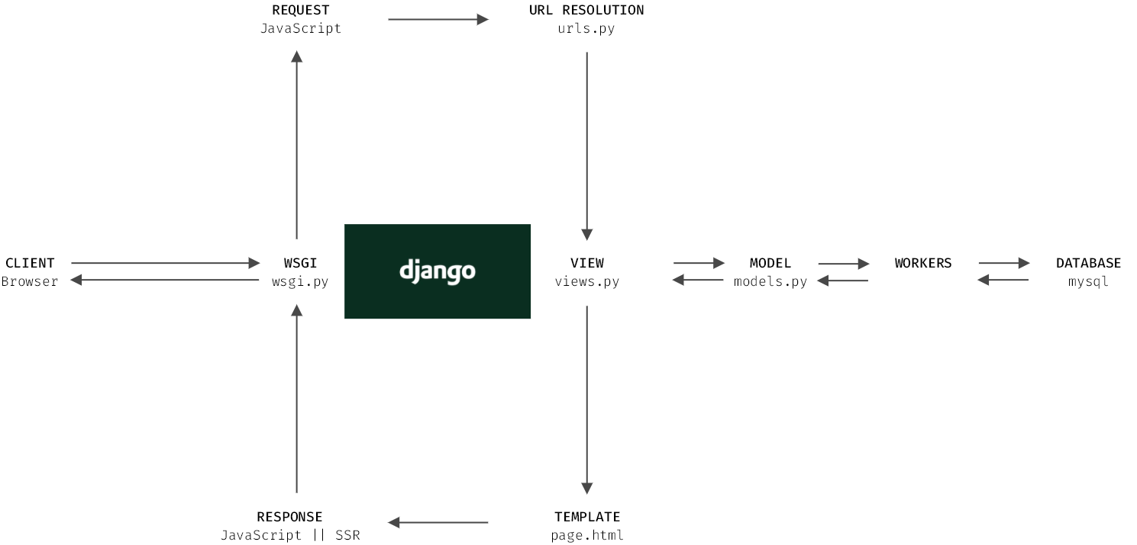

Figure 20: Request structure on Django

|  |  |
| --- | --- |
| Architecture | MVT |

Django is built on MVT(Model-View-Template) architecture model. MVT is similar to another architecture model, MVC. We can examine MVT in 3 layers

* **Model** – This layer works towards data processing. In this layer, data on the database is retrieved, changed or saved in model layer.
* **View** – In MVT design pattern, the View is deciding what data should be displayed
* **Template** - Templates is the layer that shows how to transfer data to users with help of templates. An example is a Generic list view that we can use to display a set of records from the database.

In Django you don’t have to write any code related to fetching data from database and mapping it with URL requests. All these actions are handled by the Django itself. The one thing we must do is to tell Django what data should be rendered to the user. Django will then create a view based on the data and render it to the user.

## Database Design

In this section, we will detail our database design considering the future requirements of our online auction application.

As seen in Figure 17, our database consists of 12 models. We will integrate the database tables in the figure into our application via MySQL.

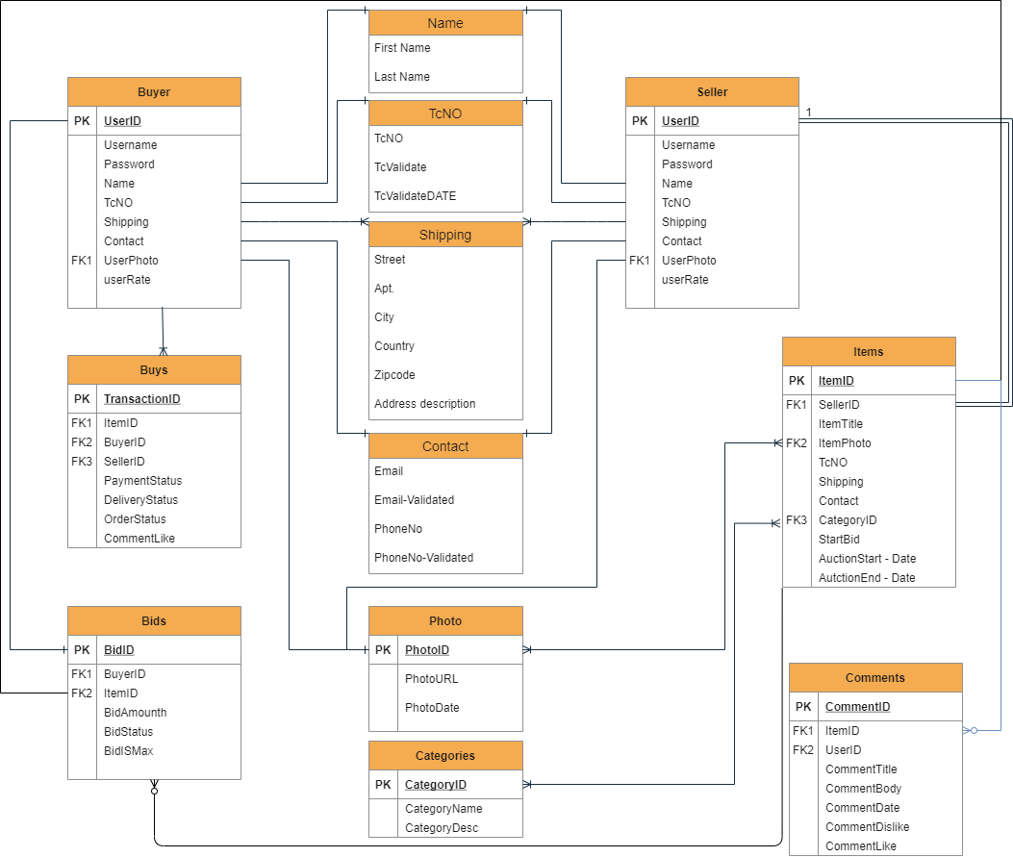

Figure 21: Database Structure

## Use-Case Diagrams

Our online auction application defines different functional features for the registered and non-registered users. In this section, we will explain what users in these different roles can and cannot do on the online auction application.

### Non-Registered User Use-Case Diagram

As seen in the UML diagram, unregistered users are restricted from using all the features of our application, unlike registered users. Our users who want to use all the features can register by entering their name, surname, email address and password on the registration page. In the registration process, the system scans whether the same information has been used before in the database and warns the user in case of any match.

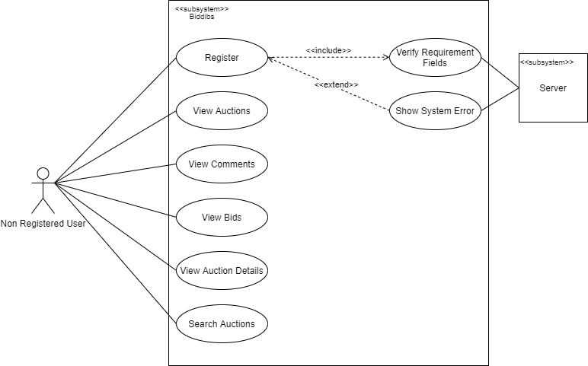

Figure 22: Non-Registered user use-case diagram

### Registered User Use-Case Diagram

As seen in the UML diagram, users registered in the system can use most of the features. Registered users can edit their specially created profiles, evaluate auctions, post comments on auctions or send messages to other users. Registered users can log in to the system on the “login page” with the e-mail and password information they used while registering. The system searches the database for the information entered by the user on the "Log In" page and warns the user if no match is found.

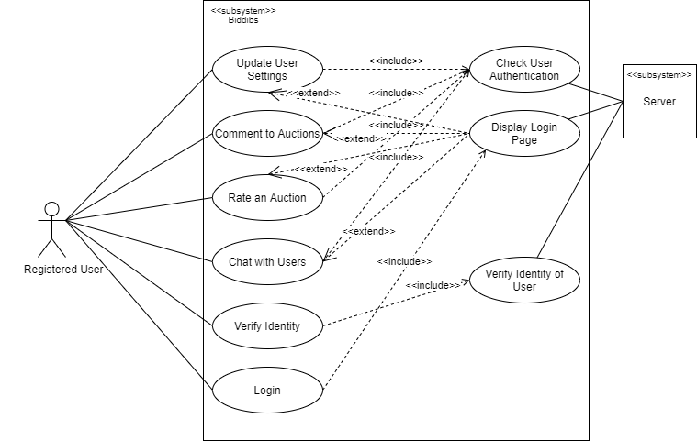

Figure 23: Registered user use-case diagram

### Identity Verified User Use-Case Diagram

As seen in the UML diagram, users who have completed identity verification can create, edit, delete or submit bids to other users' auctions after gaining a vote of confidence.

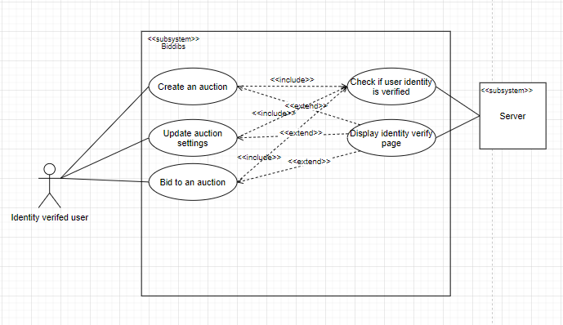

Figure 24: Identity verified user use case diagram

## Sequence Diagrams

The diagrams in this section depict the communication between user, system and database in our online auction application.

### Register Sequence Diagram

After the user enters the necessary information on the registration page, the system searches the database to see if the same mail or phone number has been used before. If this information has been used before, the user will be warned. If this information has not been used before, the user's information’s will be saved in the database and the user will be redirected to the home page.

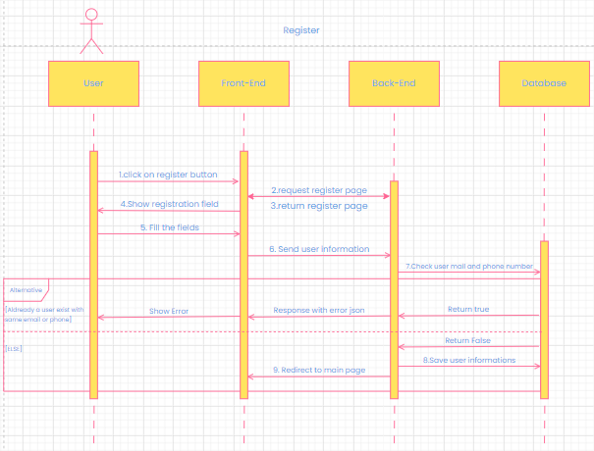

Figure 25: Register sequence diagram

### Login Sequence Diagram

After the user enters the mail and password information on the login screen, the system validates of this information in the database. If the information provided by the user is correct, the system provides the user with a unique session and redirects to the home page. If the information entered by the user is incorrect, the user will be warned.

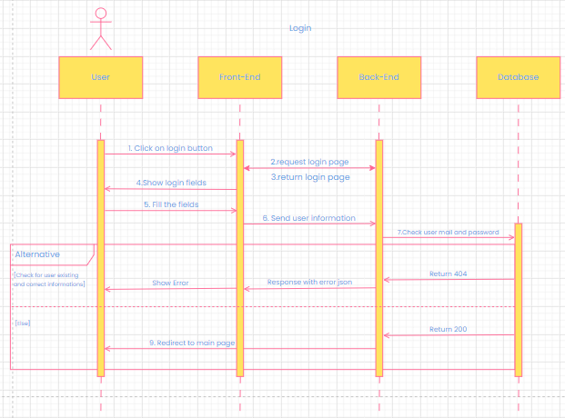

Figure 26: Login sequence diagram

### Create an Auction Sequence Diagram

After the user clicks the “create an auction” button, the system checks if the user has a session. If the user is not logged in, system will redirect the user to the "Log in" page. The system checks whether logged in users have verified their identity. Users with not verified identities are directed to the "verify identity" page. The system saves the information entered on the “create an auction” page by the logged in and identity verified users in the database.

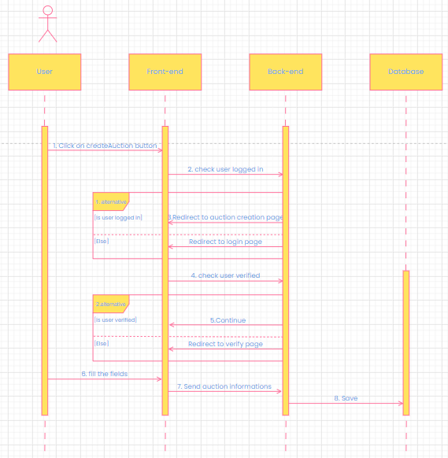

Figure 27: Create an auction sequence diagram

### Comment an Auction Sequence Diagram

After the user clicks the “Send a comment” button, the system checks if the user is logged in. If the user is not logged in, the system redirects the user to the "Log in" page. The system saves the logged in user's comment in the database.

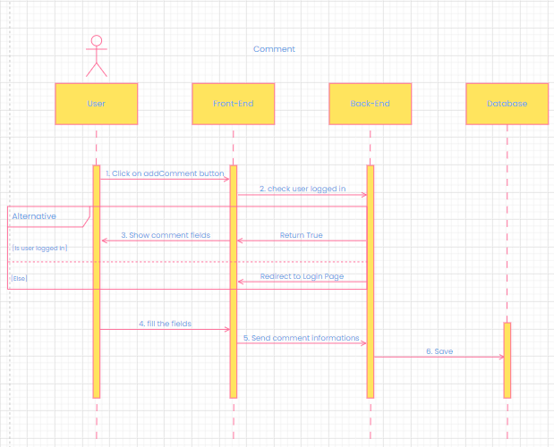

Figure 28: Comment an auction sequence diagram

### Send Bid to an Auction Sequence Diagram

When the user clicks the “Send bid” button, the system checks whether the user has a session. Users who are not logged in are redirected to the "Log in" page. Then the system checks whether the user has identity verified or not. Users who have verified their identity are directed to the "Payment API". The system saves the bid to the database after the "Payment has been made" message returned from the "Payment API".

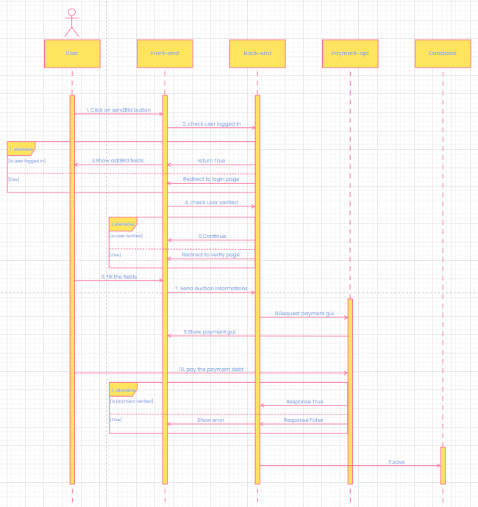

Figure 29: Send bid to an auction sequence diagram

## Class Diagrams

Let’s take a look to how class structure looks like with UML diagram in figure 25.

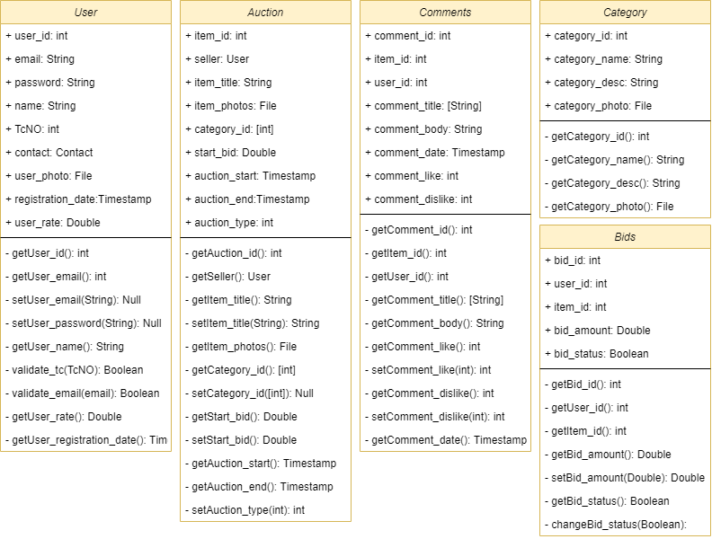

Figure 30: Class UML

# REFERENCES

[1] <https://foundation.app/>

[2] <https://www.peramezat.com/>

[3] <https://www.ebay.com/>

[4] <https://www.djangoproject.com/>

[5] <https://en.wikipedia.org/wiki/Web_browser>

[6] <https://github.com/ianb>

[7] <https://github.com/pypa/pip/graphs/contributors>

[8] <https://pypi.org/project/pip/>

[9] <https://scalegrid.io/blog/2019-database-trends-sql-vs-nosql-top-databases-single-vs-multiple-database-use/>

[10] [https://kinsta.com/cloudflare-market-share/#:~:text=Cloudflare%20Is%20Used%20by%2081.2,Rely%20on%20Content%20Delivery%20Networks&text=By%20the%20numbers%2C%20Cloudflare%20is,CloudFront%2C%20Akamai%2C%20and%20Fastly.](https://kinsta.com/cloudflare-market-share/%23:~:text=Cloudflare%20Is%20Used%20by%2081.2,Rely%20on%20Content%20Delivery%20Networks&text=By%20the%20numbers%2C%20Cloudflare%20is,CloudFront%2C%20Akamai%2C%20and%20Fastly.)

[11] <https://en.wikipedia.org/wiki/SSL>

[12] <https://www.cloudflare.com/>

[13] <https://www.mysql.com/>